EAN 5901804191138 | CB NUMBER T1501
Vendor Art. Nr 1804191138

Ouse

Main description
Fancy radiator perfectly reconciling decorative function and usability. It makes a real statement both in bathrooms and living rooms.

Key points
- Unique form and finish
- Original and functional decorative element
- Minimalism and pragmatism taken to extremes

Features and benefits
- Highest quality low carbon steel ensuring product longevity
- Great towel hanging capability
- Easy installation (solid wall fixing kit included)
- Made to EN 10305-5
- Easy cleaning and maintenance
- Hand polished surface ensuring state-of-the-art galvanic coating

Specifications
Height (mm): | 1437
Width (mm): | 500
Depth (mm): | 95
Colour: | Galvanic Old Copper
Heat output (W): | 391
Heat output (BTUs): | 1334
Connection type: | ZX
Connection spacing: | 50
Wall to centre of inlet (mm): | 73-88
Operating pressure (MPa): | 1
Maximum operating temperature (°C): | 95
Material: | Carbon steel
Surface finish: | Galvanic coating
Weight (kg): | 14.8

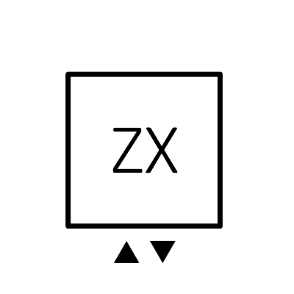
Connection diagram

